SMERSET PALACE Hotel (November 6 ~ 8 / 20 people)
- 7, Yulgok-ro 2-gil, Jongno-gu, Seoul (Anguk Station)
- 1 night's accommodation: 187,000 WON
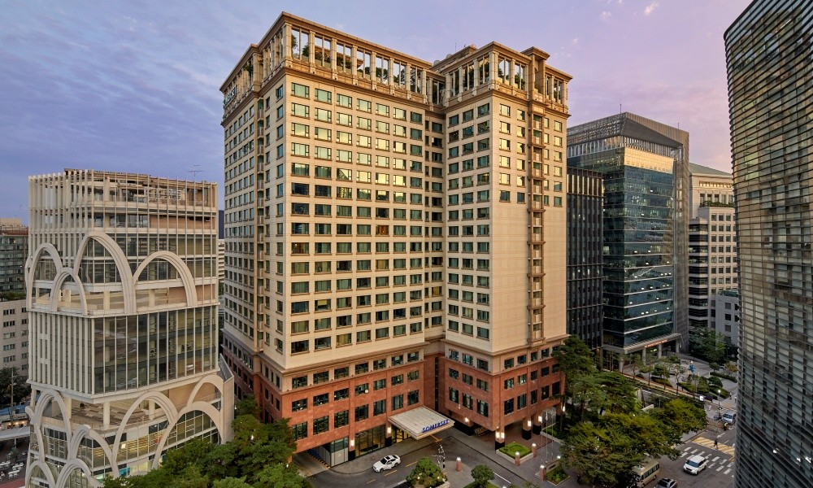

Seoul Dragon City Hotel (November 6 ~ 8 / 20 people)
- 95, Cheongparo 20-gil, Yongsan-gu, Seoul (Yongsan Station)
- 1 night's accommodation: 192,500 WON (Level 4) / 242,000 WON (Level 5)
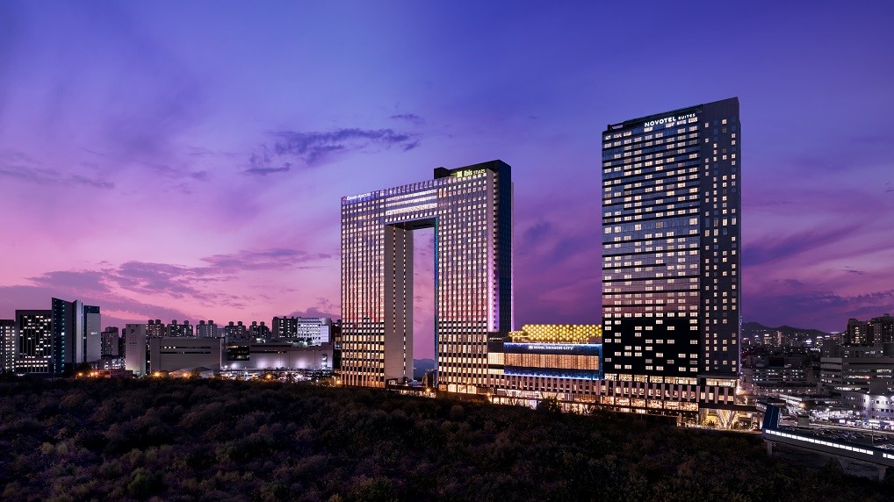
Orakai Hotel (November 6 ~ 8 / 20 people)
- 180, Yulgok-ro, Jongno-gu, Seoul (Hyehwa Station)
- 1 night's accommodation: 184,800 WON
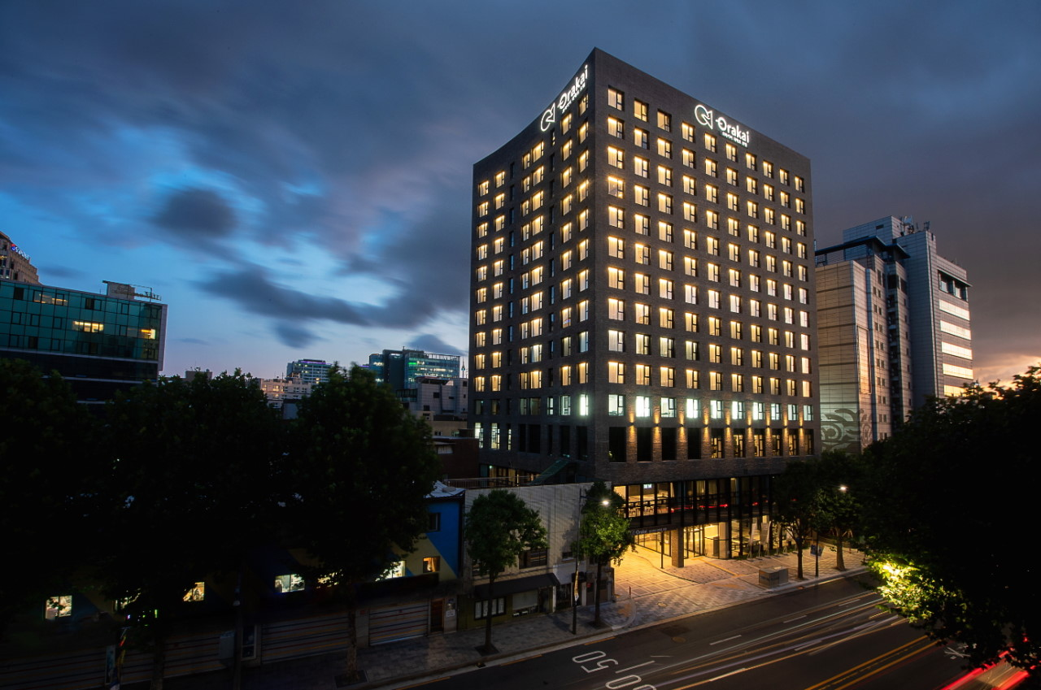

Arirang Hill Hotel (November 6 ~ 8 / 20 people)
- 8, Arirang-ro, Seongbuk-gu, Seoul (Sungshin Women's University Station)
- 1 night's accommodation: 165,000 WON
